Intro-to-Rock- Information Packet

Friday, April 21-Sunday, April 23, 2017

Trip Leader:

Elliott Hoppe (elliotthoppe@gmail.com - 206-790-3455)

Chaperones:

Travel & Start Times
- Travel time from Seattle: 2 hours, 20 mins
- 3:00 pm - leave GHS (staff parking lot behind gym, on 25th Ave.)
- 5:30 pm - Arrive at Frenchman Coulee

Map & Directions
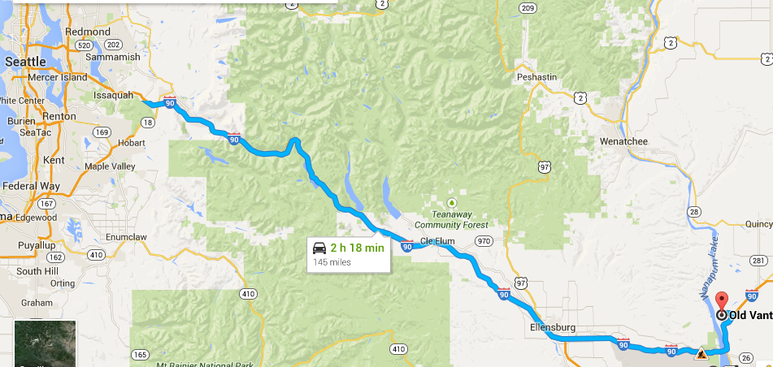
Frenchman Coulee
Old Vantage Hwy
Quincy, WA 98848

Trip Description & Objectives
For this trip student participants will learn and/or practice rock climbing techniques in a safe and beautiful location. All routes will be top-roped with permanent anchors/bolts, and students will have many opportunities to climb while being belayed by experienced instructors. Participants will also learn how to tie a variety of knots, and will learn safe climbing protocol and communication. Students will also have the opportunity to learn how to belay but there will always be a back-up belay by an instructor when students are practicing. Only rock staff and instructors will belay climbers without the back-up.

Trip Preparation
Pack all the required items on the packing list. Check with Elliott if you don’t have one of the items and need borrow it.
Go to Facebook Page (Intro to Rock 2017) to make a tent group and food group--when you have your group, communicate about who is bringing what (see packing list for meals needed, and suggestions)

Week before Intro to Rock:
- If possible, attend the practice/intro session at the Mountaineers Wall in Magnusen Park, on _________ from 5:30-7:00
- Make sure you have all your required gear for the weekend.

Night before Intro to Rock:
- Pack using the provided packing checklist
  - Do not wait until the morning to pack!

Permits & Carpool
- Discover Pass is required for all cars parked at Frenchman Coulee campground.

Trip Policies and Safety Procedures

Be punctual and stay with the group
- Check in with trip the leader at GHS, and be in the parking lot ready to load carpools no later than 3:00 on Friday, April 21
- Talk to the chaperone or trip leader if you need to leave the group for any reason.

Communicate
- Talk to the trip leader or one of the chaperones if you have any needs that arise that would compromise your ability to participate safely and comfortably
- Communicate with the trip leader if you see anything that looks or feels dangerous, or if you or another participant gets hurt.

Follow all rules and safety procedures!

Rock climbing is inherently dangerous. If participants do not follow the rules they will be endangering their own lives and the safety of others. The trip leader, staff and climbing instructors are doing everything possible to minimize risks and to ensure the experience is fun, challenging and safe. We will be reviewing and talking about safety throughout the trip, but a few of the most important rules are:
- Students must wear a helmet at all times when approaching and standing near rock. When standing in the fall zone, and when climbing students and adults must wear a climbing-approved helmet. (We have enough for students who do not have their own).
- Do not distract the climbers or belayers by joking around or otherwise being a nuisance or disturbing the communication between climbers and belayers.
- Stay with the group--or a buddy-- at all times
- Follow Leave-no-trace guidelines, and stay on designated trails
- Do not boulder or scramble on rock above your shoulder height, or lower, depending on the terrain below you.
- Watch your step and use good common sense to keep yourself and others safe

Packing List

Clothing
- Rain/Wind gear (shell)
- Warm layers – gloves, warm sweatshirt or fleece, hat, extra socks, etc.--it gets cold at night!
- Base / mid layers--long sleeve shirt, long underwear or sweat pants
- Underlayers, and tee shirt
- Solid, closed-toed shoes (required)
- Climbing shoes (optional)

Essentials

- Sleeping bag, and possibly even an extra blanket
- Tent (share with group)
- Camp stove and pots (share with group)
- Bowl and eating utensils
- Sleeping pad & pillow
- Sun Protection – lip balm, SPF, sunglasses, hat, etc.
- Water: Two 32 oz water bottle (full)-there is no water at the campsite, we will fill all water bottles before we leave! Trip leader and chaperones will be bringing additional water.
- Headlamp and/or flashlight
- Toiletries and personal first aid items

Climbing Gear (OPTIONAL--Bring it if you have it, and trust it!)
- Climbing helmet
- Harness
- Climbing shoes

Food--arrange most of this with your food group
- Two breakfasts (Saturday and Sunday)--e.g. oatmeal, granola, bars
- Two lunches (Saturday and Sunday)--e.g. bagels, cream cheese, p.b. & j, fruit, cookies
- Two dinners (Saturday and Sunday)--e.g. dehydrated dinners (just add water) are easiest.
- Snacks!--bring plenty of food you can pack and eat on the fly--e.g. jerkey, energy bars, g.o.r.p.

Misc
- Cell phone
- MUSICAL INSTRUMENTS HIGHLY ENCOURAGED
- Cash for snacks on the road

Don’t hesitate to contact your trip leader prior to Friday if you have any questions about gear or preparing for the weekend!

Schedule

DAY/TIME | ACTIVITY
Friday 4/21  5:30 | Arrive at Frenchman’s Coulee, set up camp
6:30 | Dinner and clean up
7:30 | Sunset hike up on the coulee
8:30 | Campfire
10:00 | Everyone in tents
Saturday 4/22
8:00 | Breakfast
8:30 | Climbing & belaying demo and safety protocol  Knots--beginning or advanced
10:00 | Climbing and Belaying at “The Sunshine Wall”
12:30 | Lunch
1:30 | Hike and/or Continue Climbing
5:00 | Return to camp for down time
6:30 | Dinner and clean up
7:30 | Sunset hike up on the coulee
8:30 | Campfire
10:00 | Everyone in tents
Sunday
4/23
8:00 | Breakfast
8:30 | Pack up Camp
10:00 | Climbing and Belaying at “The Feathers”
12:30 | Lunch
1:00 | Final camp clean-up--Leave no Trace
1:30 | Pack up cars and drive home
4:00 (or tbd) | Return to GHS parking lot (main lot in front of Quincy Jones)  Students will text or call with return time when we get close.

